
2014 – North Lake Senior College
Chemistry 2A/B

Name: _______SOLUTIONS____________ Date: _______________

Score: ___________ / 40 marks

Unit 2B

Acids, Bases, Empirical Formula & Limiting Reagent

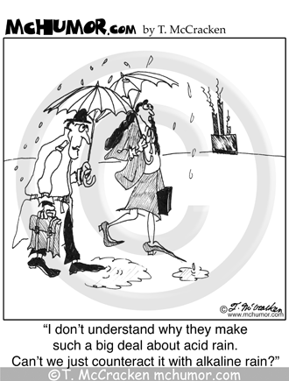

Instructions: Write the letter of the correct answers in the right-hand column.

1. Which of the following best describes a weak acid?
a) An acid which contains only one hydrogen atom in its molecular formula
b) An acid of low concentration
c) A dilute acid
d) An acid which dissociates only partially in aqueous solution | D
2. Which one of the following is NOT a property of a base?
a) Turns red litmus blue.
b) Tastes bitter.
c) Reacts with metal oxides to produce a salt and water. | C
d) Usually produces hydroxide ions in aqueous solution.
3. What is the pH of 0.01 mol L ^{–1} solution of hydrochloric acid?
a) Between 7 and 9
b) 7
c) Between 3 and 7
d) 2 | D
4. Which one of the following groups contains only BASIC oxides?
a) Na₂O, Al₂O₃, SO₂
b) MgO, ZnO, CuO
c) Na₂O, MgO, CuO | C
d) CO₂, MgO, NO₂
5. Which one of the following oxides reacts with both HCl and NaOH?
a) CuO
b) Al₂O₃ | B
c) MgO
d) CaO

6. Consider the following statements.
1. Acids are substances which produce hydrogen ions in aqueous solution.
2. Acids are proton donors.
3. Bases are substances which ionise in water to produce hydroxide ions.
4. A base is a proton acceptor.
Which, if any, are consistent with the Arrhenius theory of acids and bases?
a) 1 only.
b) 1 and 2.
c) 2 and 4.
d) 1 and 3. | D
The next 2 items refer to the following equations
- I Mg(s) + 2H₃O⁺(aq)  Mg²⁺(aq) + H₂(g) + 2H₂O
- II H₃O⁺(aq) + OH⁻(aq)  2H₂O
- III HS⁻(aq) + H₃O⁺(aq) H₂S(aq) + H₂O
7. Which of the above equation/s represents acid – base reaction/s?
a) I only
b) I and II
c) II and III | C
d) II only
8. Which of the following is acting as a base?
a) Mg
b) H₃O⁺
c) H₂S
d) HS⁻ | D
9. Which of the following equations is NOT balanced?
a) 2H₂S(g) + 3O₂(g) 2H₂O(g) + 2SO₂(g)
b) 2C₂H₆(g) + 7O₂(g) 4CO₂(g) + 6H₂O(g)
c) HCl(aq) + NaOH(aq) H₂O(l) + NaCl(aq)
d) 3NO(g) + 2O₂(g) 3NO₂(g) | D
10. 20.0 cm³ of oxygen is reacted with 16.0 cm³ of carbon monoxide to produce carbon dioxide gas. If all gas volumes are measured at the same temperature and pressure, what would be the final composition of gases when the reaction is complete?
2CO(g) + O₂(g) 2CO₂(g)
a) 40 cm³ of CO₂
b) 12 cm³ of O₂ and 16 cm³ of CO₂ | B
c) 8 cm³ of O₂ and 40 cm³ of CO₂
d) 8 cm³ of O₂ and 16 cm³ of CO₂

The next question refers to the equation below which shows the decomposition of zinc carbonate upon heating.
_{heat}
ZnCO₃(s) ZnO(s) + CO₂(g)
11. If 2.5 g of zinc carbonate is heated, what mass of zinc oxide would be produced?
a) 0.02 g b) 0.8 g
c) 1.6 g d) 3.2 g | C
The next question refer to the displacement reaction which occurs when zinc metal is placed in a solution of copper sulfate.
Zn(s) + Cu²⁺(aq) Zn²⁺(aq) + Cu(s)
12. Consider the FOUR statements below which describe what may happen in the above reaction:
I. The colour of the solution becomes paler.
II. The zinc metal becomes coated with copper metal.
III. The colour of the solution does not change.
IV. The solution changes to a more intense blue colour.
Which of these statements is/are true?
a) I only.
b) II only.
c) I and II. | C
d) II and III.
13. A small amount of salt when added to a salt solution, dissolves. From this we can conclude that the original salt solution was
a) concentrated.
b) dilute.
c) saturated.
d) unsaturated. | D
14. Which one of the following pairs of solutions, when mixed , would NOT produce a precipitate?
a) Magnesium nitrate and sodium sulphate. | A
b) Sodium chloride and silver nitrate.
c) Magnesium nitrate and barium hydroxide.
d) Barium nitrate and Potassium sulphate.
15. What is the concentration ( in mol L⁻¹) of a silver nitrate solution which is made by dissolving 10.79 g of silver nitrate in 500 mL of solution?
a) 0.1 mol L⁻¹
b) 0.02 mol L⁻¹
c) 0.2 mol L⁻¹ | C
d) 0.05 mol L⁻¹

END OF SECTION
Section B —Written Answers (32 marks)

Instructions: Answer the following questions. Show working out for questions requiring calculations.

1) 5.0 g of calcium is reacted with 10.0 mL of 3.4 mol L⁻¹ nitric acid.
- Write an ionic equation for this reaction [1 mark]

- What is the limiting reagent? [3 marks]

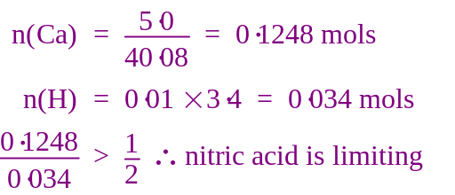

- What volume of hydrogen gas is produced by this reaction? (assume STP) [2 marks]

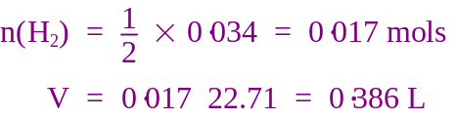

- What mass (or volume) of the limiting reagent must be added to complete the reaction? [2 marks]

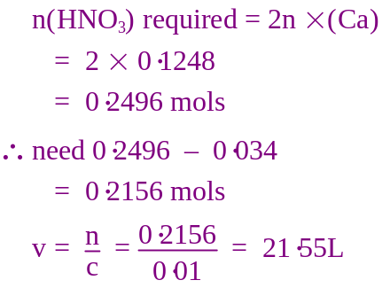

2) The following compounds are all soluble compounds form aqueous solutions. For each compound:
- State all the ions present in the solution. [5 marks]
- State whether the solution is ACIDIC, NEUTRAL or BASIC [5 marks]

Compound | Ions present in solution | Acidic Neutral or Basic
HCl | H⁺ (or H₃O⁺), Cl⁻ | Acidic
NaOH | Na⁺, OH⁻ | Basic
H₂SO₄ | H⁺ (or H₃O⁺), HSO₄⁻, SO₄²⁻ | Acidic
MgCl₂ | Mg²⁺, Cl⁻ | Neutral
H₂CO₃ | H⁺ (or H₃O⁺), HCO₃⁻, CO₃²⁻ | Acidic

3) Write an ionic equation and give the observations for the following two reactions.

a) Hydrochloric acid is added to solid copper (II) carbonate [1 mark]
Equation:

[1 mark]
Observation:
A green solid dissolves in a colourless solution to form a blue solution, small bubbles of gas are also produced

b) A solution of nitric acid is added to solid iron III oxide [1 mark]
Equation:
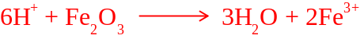

[1 mark]
Observation:
A red brown solid dissolves in a colourless solution to form a pale brown solution

4) Using equations that reflect a Bronsted-Lowry approach to the understanding of acids and bases,
show why sulfuric acid is classified as a polyprotic acid. [3 marks]

.Because it can donate more than one proton
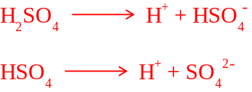

5) Students were experimenting with the reaction between concentrated hydrochloric acid (6 mol L⁻¹) and solid chunks of calcium carbonate.

(a) In a preliminary trial, they noticed that a colourless gas was produced.
Describe the test they would use to identify this gas.

The limewater test would prove it was CO₂
[2 marks]

(b) Write a balanced ionic equation for the reaction occurring between the acid and the calcium carbonate.

.....................................................................................................................................
[2 marks]

(c) How do the following change during the reaction?

(i) The mass of calcium carbonate Decrease

(ii) The Ca²⁺ concentration Increase
[2 marks]
The students recorded the volume of gas released over time:

Time (minutes) | Volume of gas (mL)
1 | 100
2 | 200
3 | 290
4 | 350
5 | 400
6 | 425
7 | 435
8 | 438
9 | 440
10 | 440

(d) Plot the information on the graph paper below. Include a heading and all labels.


[5 marks]

(e) (i) How is the rate at which the gas is evolved related to time?

The rate decreases over time

[1 mark]
(ii) Explain how this can be determined using the graph.

Gradient of the line become less

....................................................................................................................................

....................................................................................................................................
[2 marks]

(iii) Suggest a possible reason for the answer you gave in e(i) above.

Concentration of the acid decreases over time

....................................................................................................................................
[1 mark]
(f) If the volume of gas was measured after 12 minutes, what would it be?

Answer 440 mL (the limiting reagent has run out) [1 mark]

(g) (i) If the temperature of the acid was increased from 20ºC (room temperature) to 40ºC, how would that affect the rate of the reaction?

Answer: Increase [1 mark]

(ii) Explain in detail how and why this happens.

A greater number of particles have the required activation energy.

....................................................................................................................................
....................................................................................................................................

....................................................................................................................................
[2 marks]

6. An organic compound contains carbon, hydrogen and nitrogen only. It was found to contain 54.5% carbon and 13.7% hydrogen by mass. It was also has a molar mass of 60 g mol⁻¹.
a) Determine the empirical formula of this compound. [3 marks]

 | C | H
Mass (g) | 54·5 | 13·7
n | 4·537 | 13·59
ratio | 1 | 2.99

Formula = CH₃

b) What is the molecular formula of this compound? [1 mark]

M(CH₃) = 12·01 + 3× 1·008 = 15·034 g mol⁻¹

15 × 4 = 60

Molecular formula = C₄H₁₂

END OF TEST

